**LAB ASSIGNMENT- 01**

**1. Write a program to use the mathematical operators**

a=4

b=2

print("Addition:"+str(a+b))

print("Subtraction:"+str(a-b))

print("Multiplication:"+str(a*b))

print("Division:"+str(a/b))

**OUTPUT-**

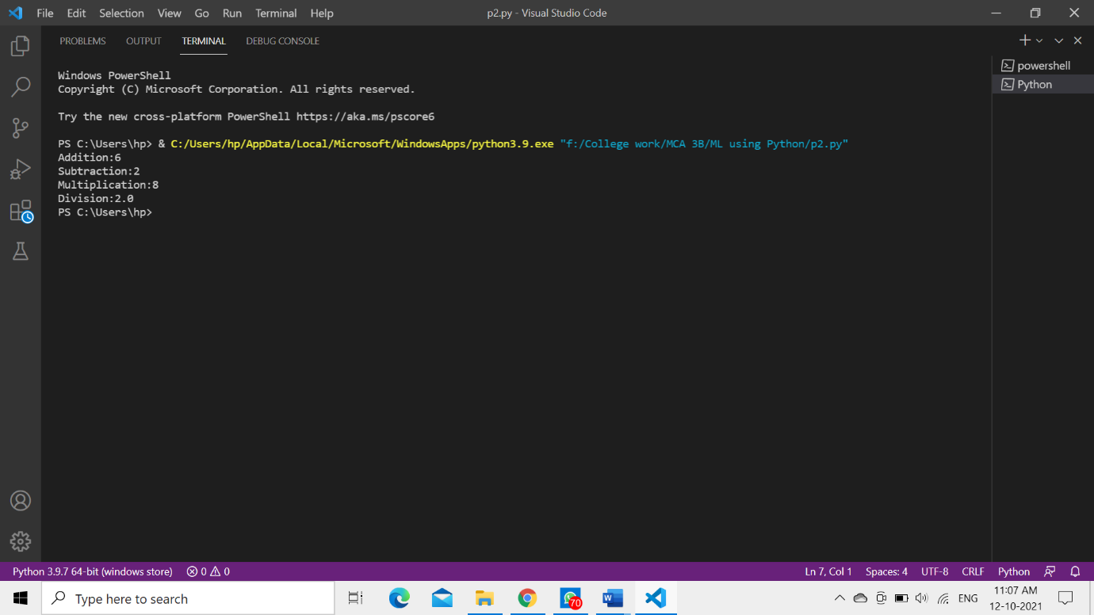

**2. Write a program to take an input of numbers from the user and print the Fibonacci series to the terminal number.**

n=int(input("Enter a number:"))

x=0

y=1

print(x,y,end=" ")

temp=x+y

for i in range(2,n):

temp=x+y

x=y

y=temp

print(temp,end=" ")

**OUTPUT-**

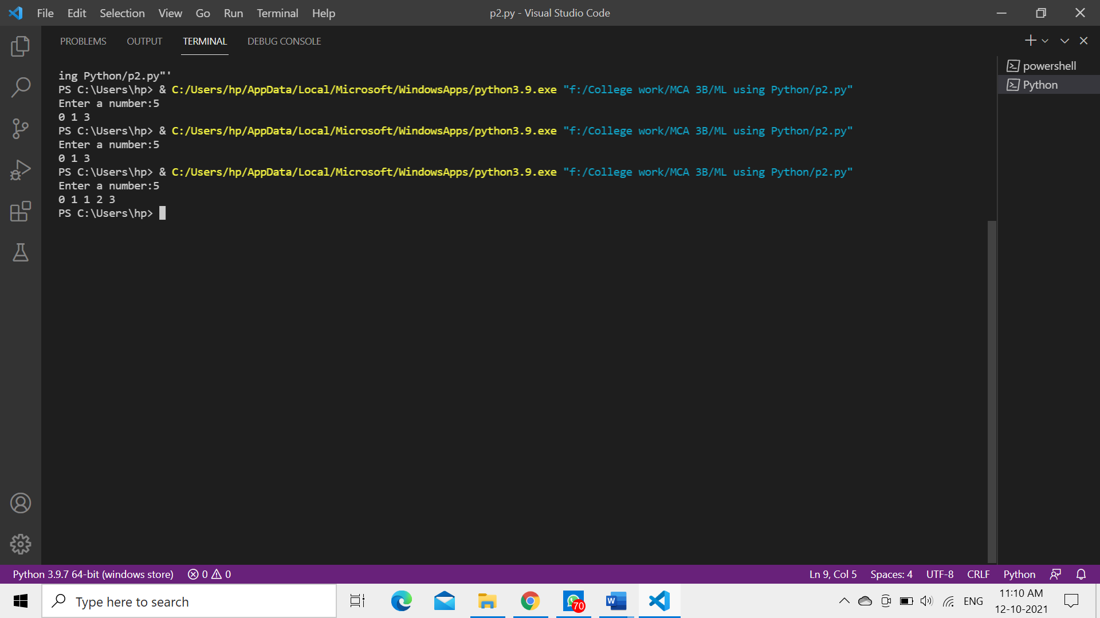

**3. Write a program to print the factorial of the number input by the user.**

n=int(input("Enter a number:"))

fact=1

for i in range(1,n+1):

    fact=fact*i

print(fact)

**OUTPUT-**

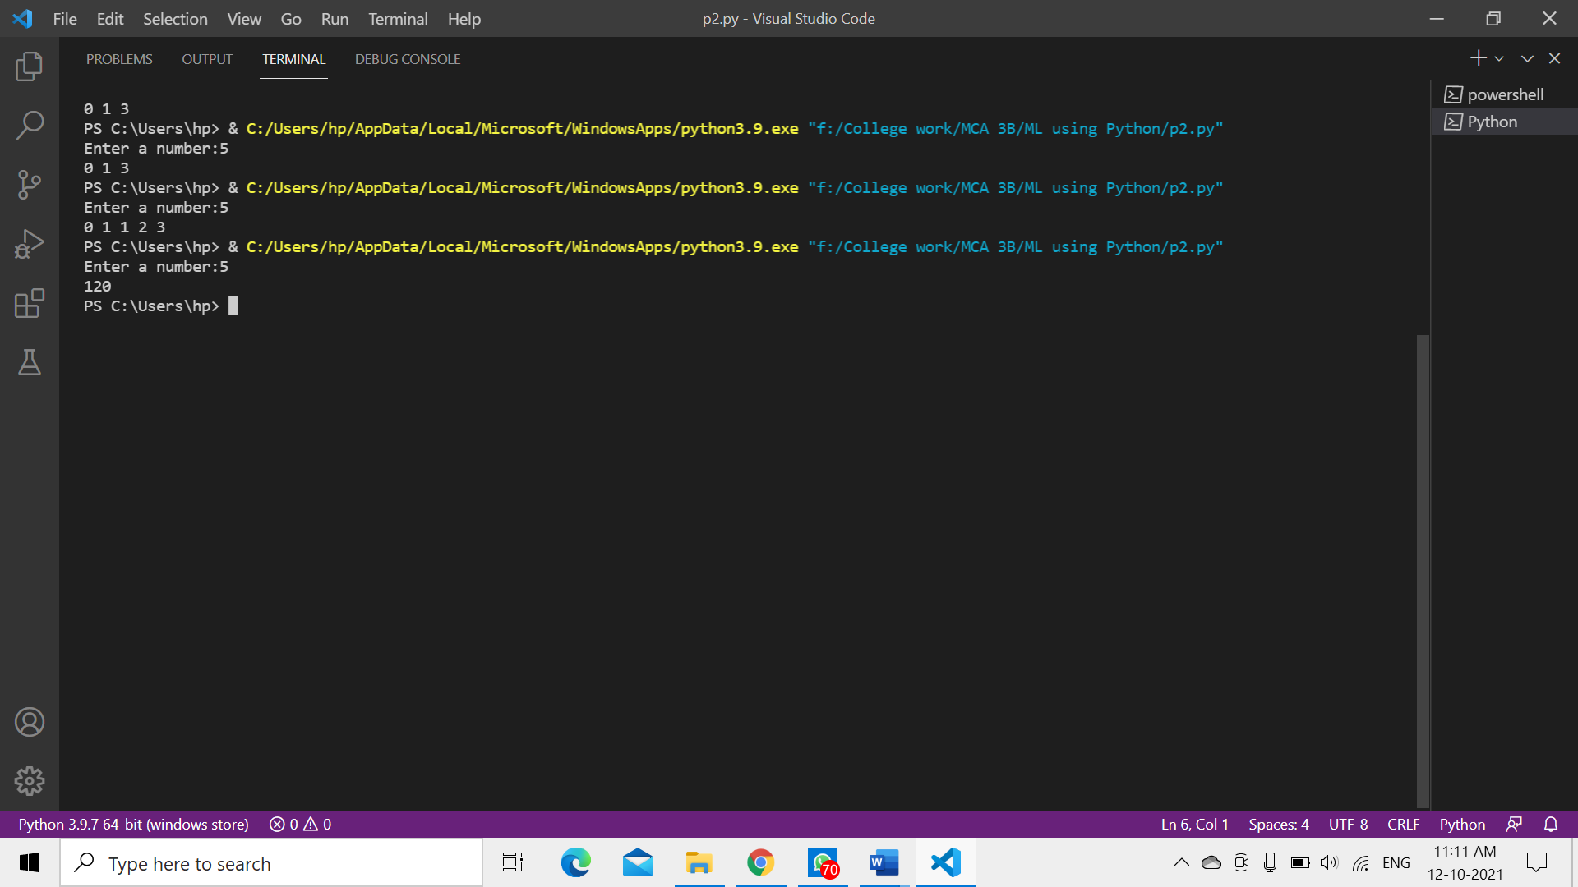

**4. Write a program to check whether a given number is a prime number or not using loops.**

n=int(input("Enter a number:"))

flag=0

if n==0 or n==1:

    print("0 and 1 are neither prime nor composite numbers")

else:

    for i in range(2,n):

        if n%i==0:

            flag=1

            break

    if flag==1:

        print("Number is not a Prime number.")

    else:

        print("Number is a Prime number")

**OUTPUT-**

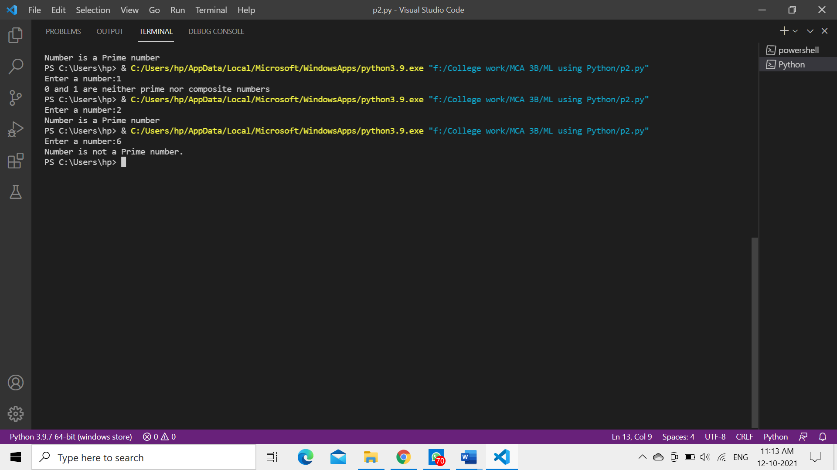

**5. Write a program to demonstrate the importing of modules of python.**

**File- modulePython.py**

def calculate(a,b):

    return (a*b)

**File- p2.py**

import modulePython

print(modulePython.calculate(2,5))

**OUTPUT-**

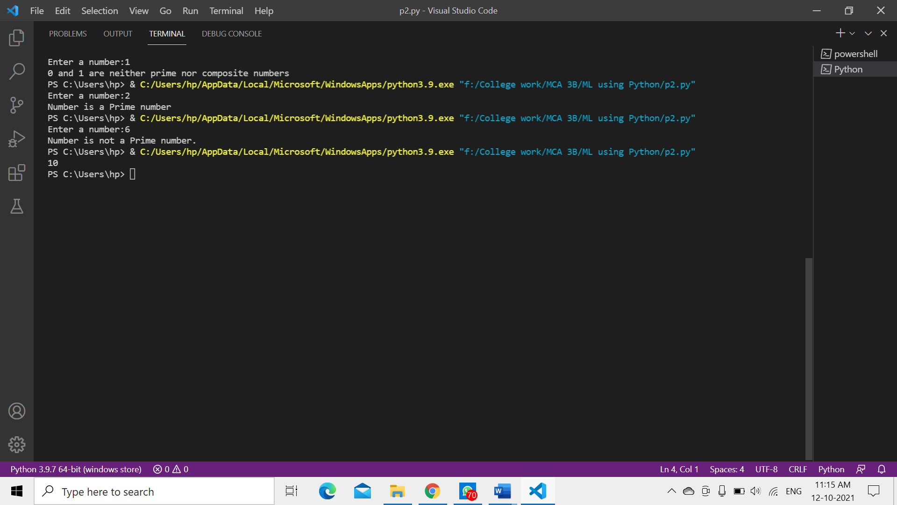

**6. Write a program to demonstrate the use of nested if statements**

i=10

if i==10:

    if i<8:

        print("i is less than 8")

    if i>8:

        print("i is greater than 8")

**OUTPUT-**

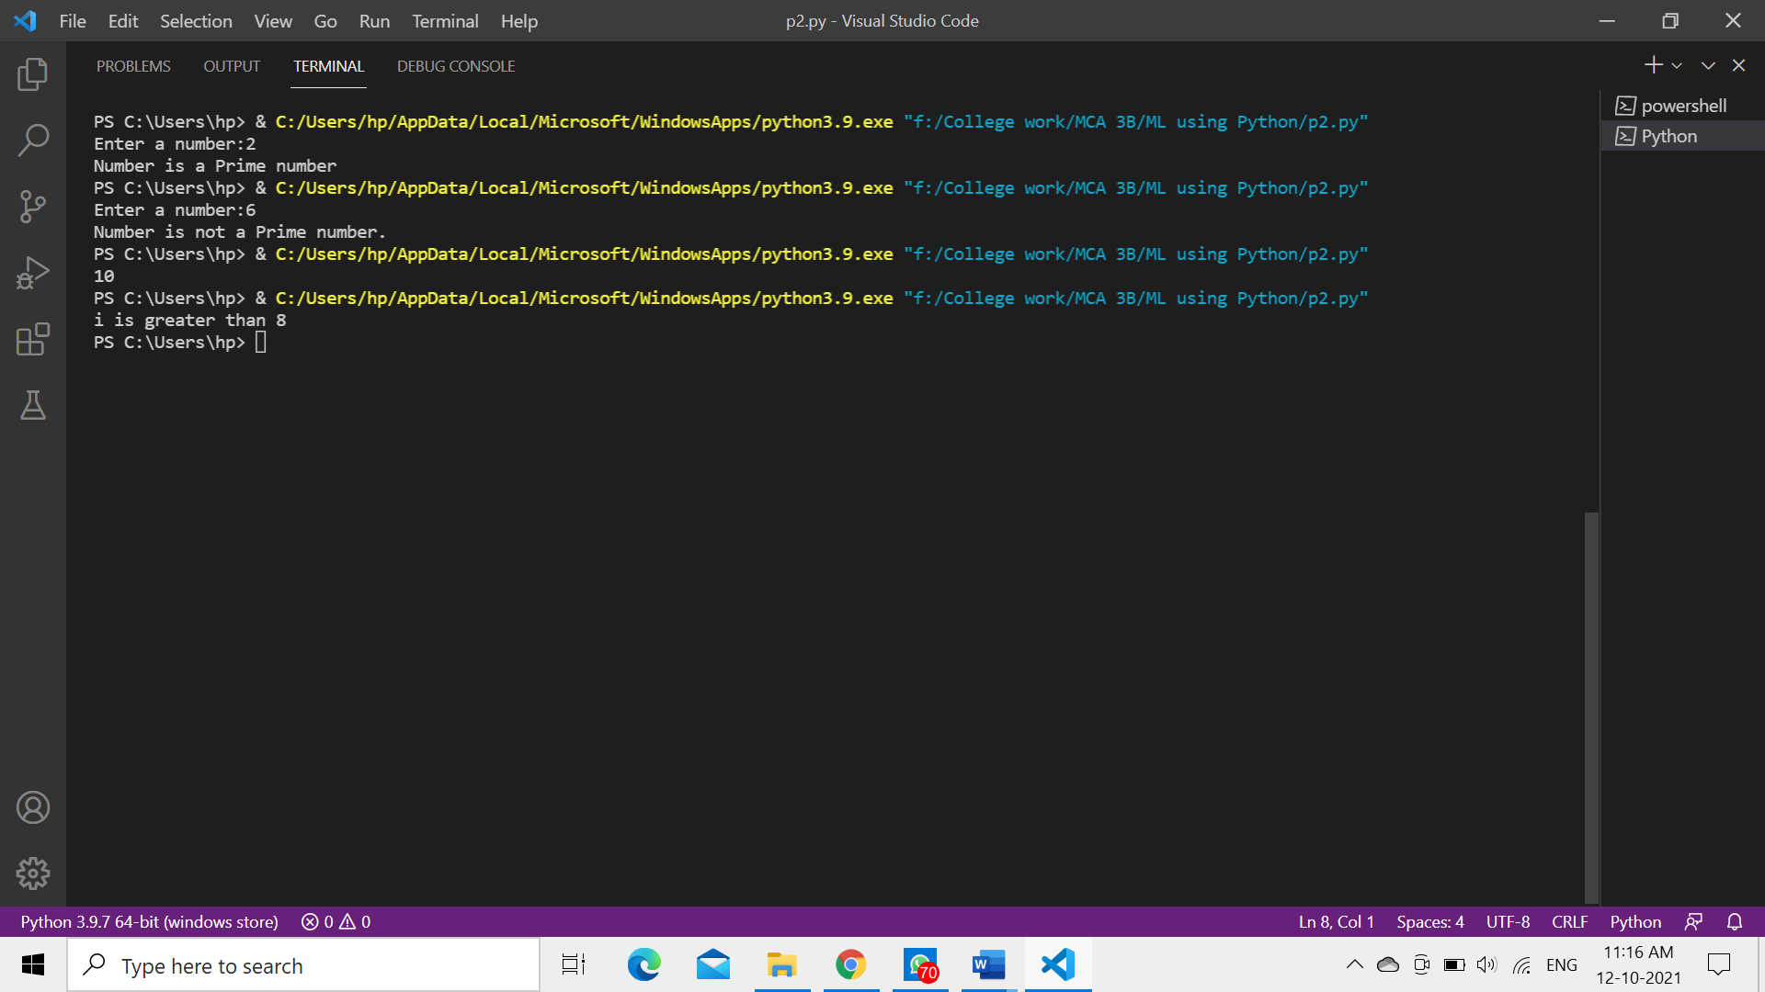

**7. Write a program to demonstrate the use of the else clause.**

for i in range(1, 5):

    print(i)

else:

    print("For Loop End...!!!")

**OUTPUT-**

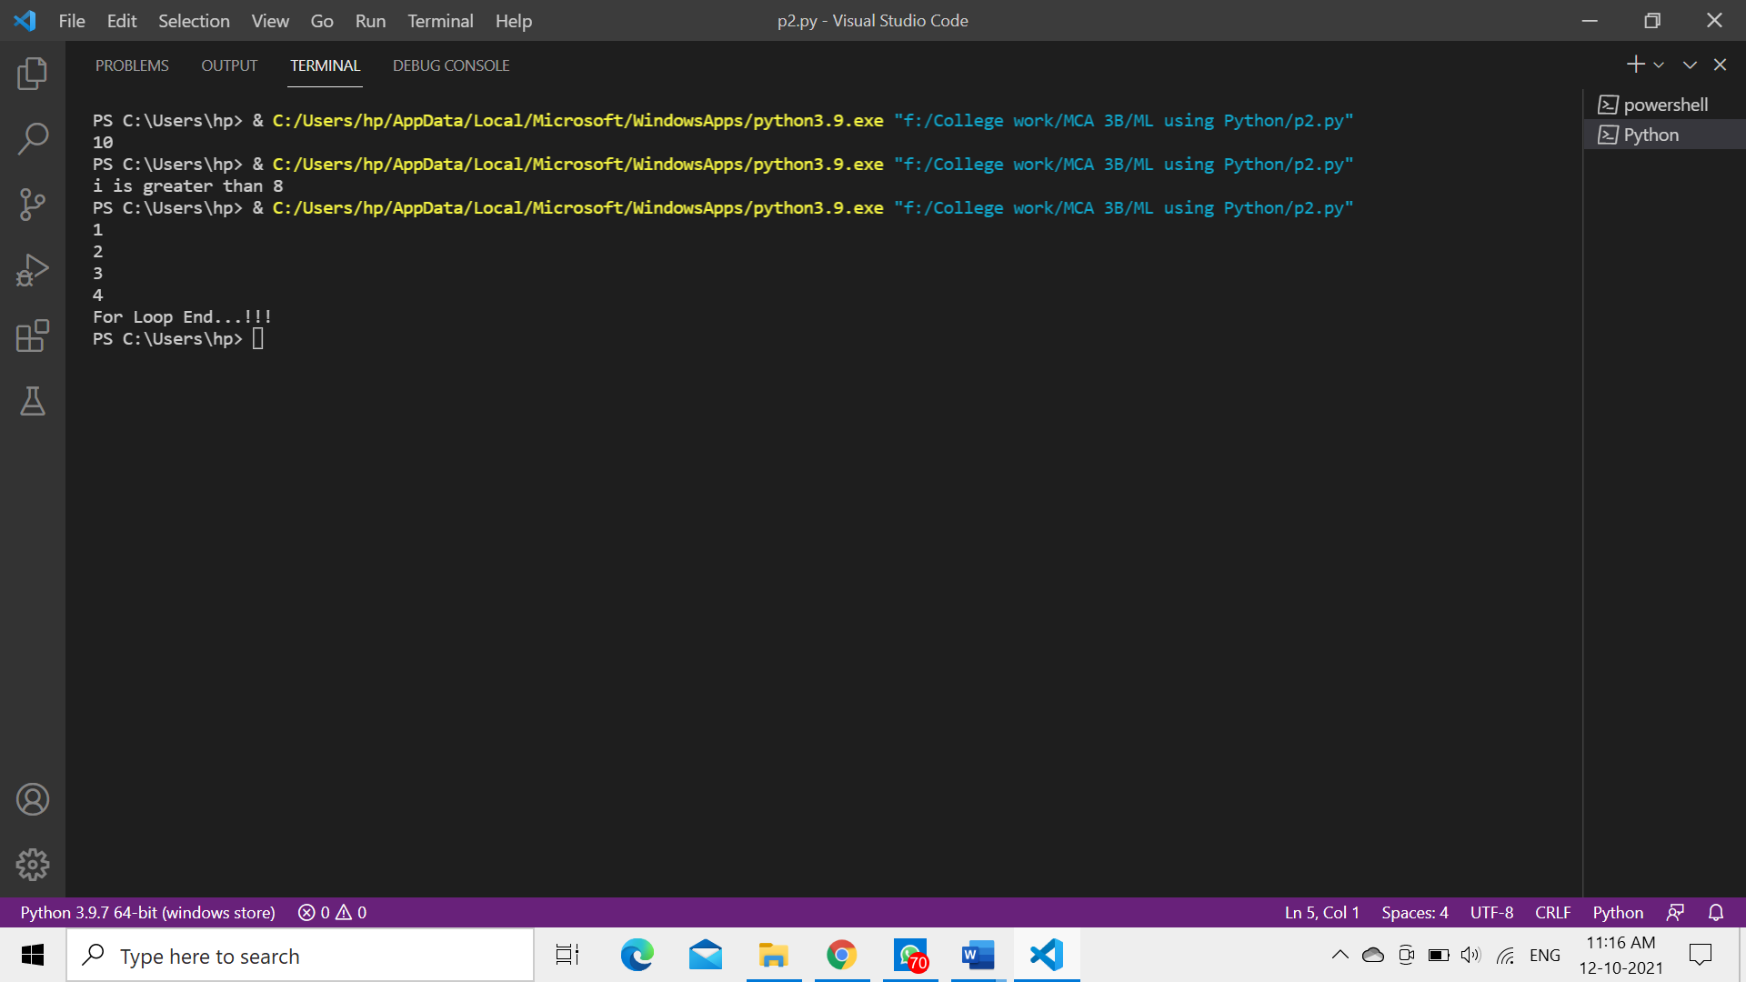

**8. Write a program to illustrate the usage of Tuples.**

t=()

print("Type: ",type(t))

t=("Shivani",18,False,8,"Semwal")

print(t[0:])

**OUTPUT-**

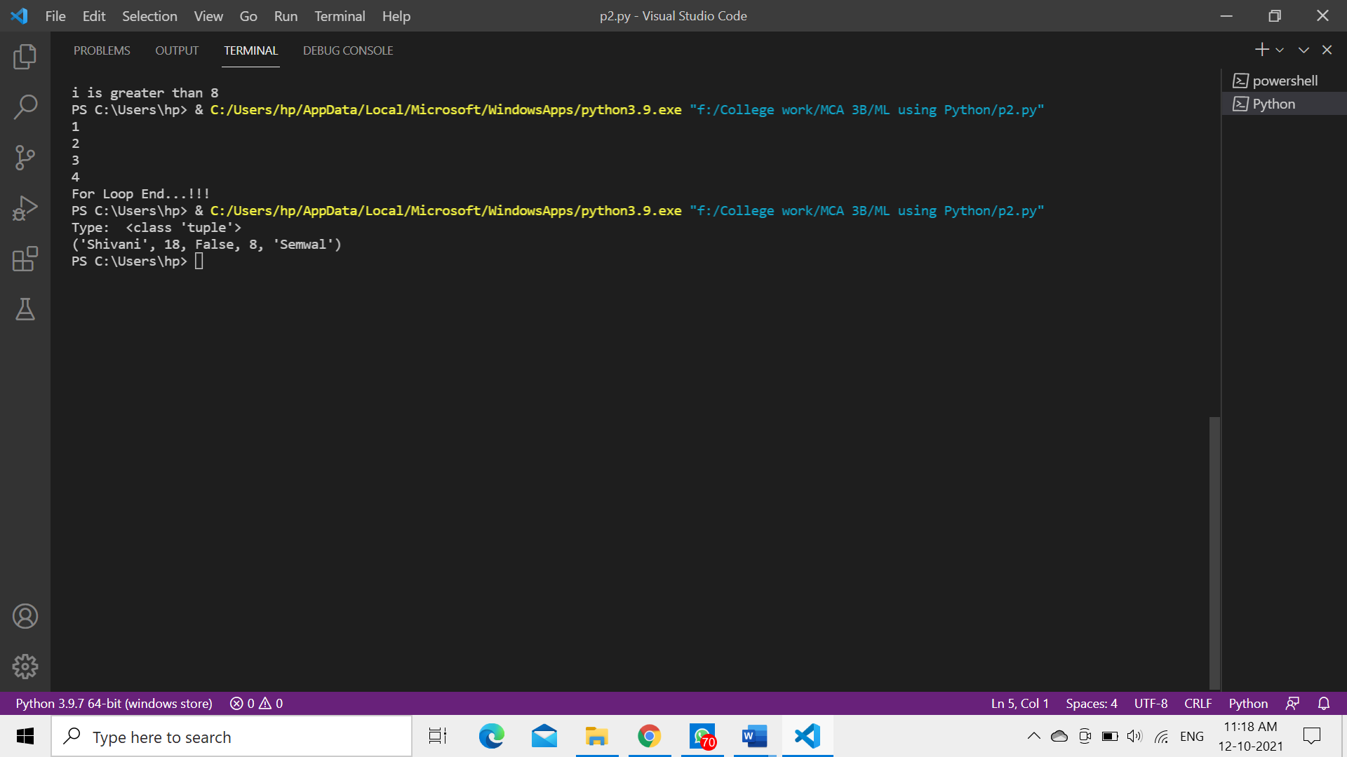

**9. Write a program for searching an element and sorting a List.**

l=[3,5,18,10,16,8,0,7]

n=int(input("Enter element to be search:"))

flag=0

for i in range(0,len(l)):

    if l[i]==n:

        flag=1

        break

if flag==1:

    print("Element Found...!!!")

else:

    print("Element not Found...!!!")

l.sort()

print("List after sorting:",l[0:])

**OUTPUT-**

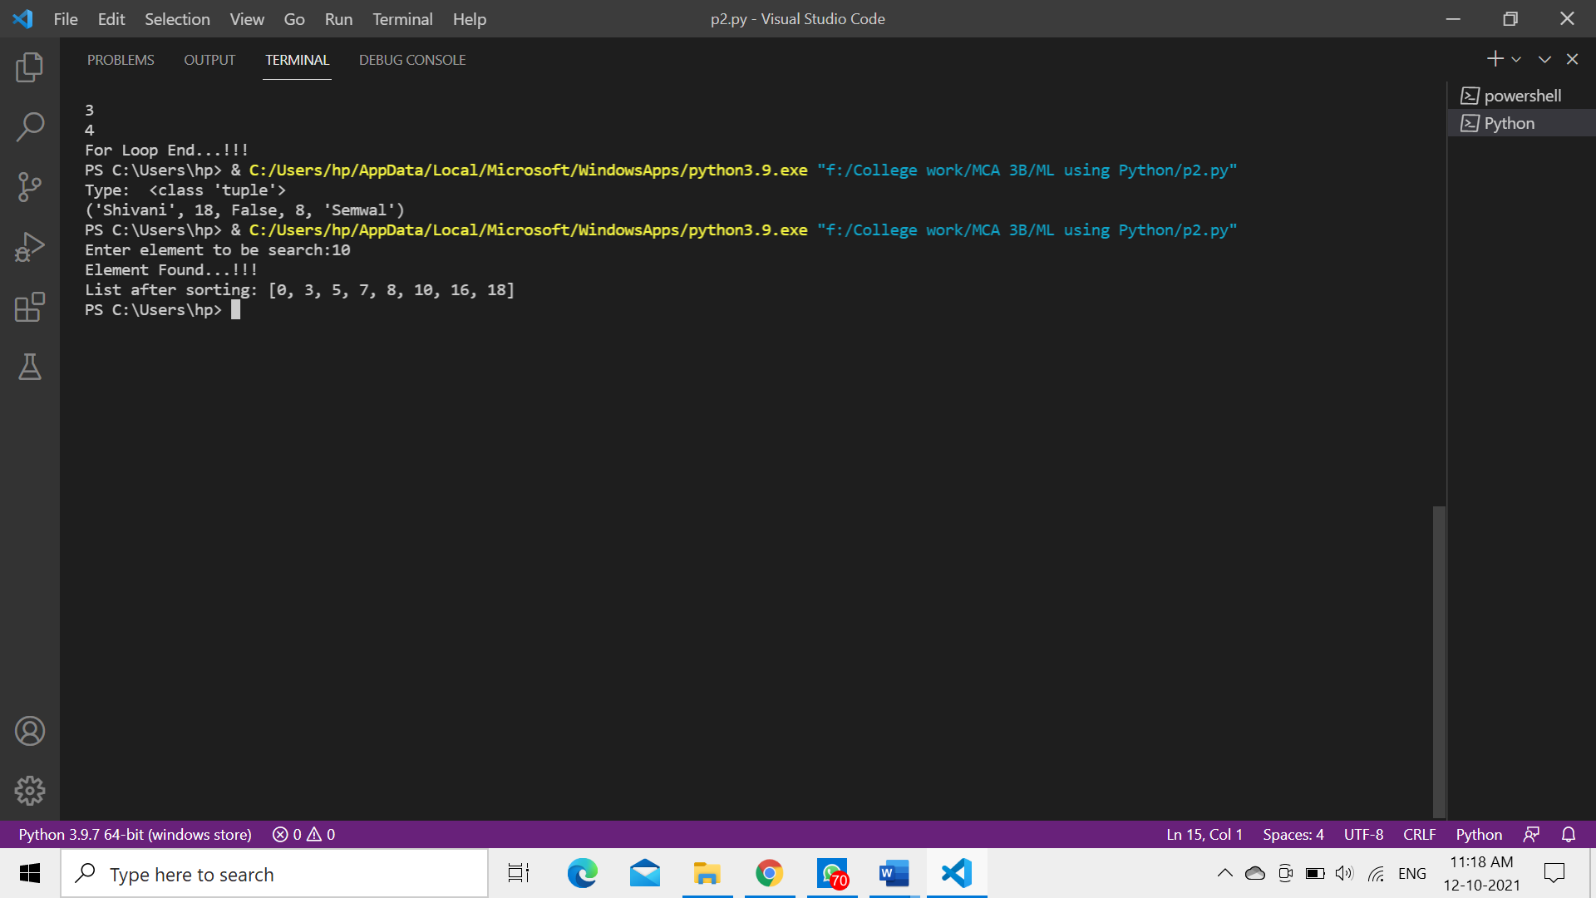

**10. Write a program to illustrate the usage of Dictionaries.**

d={

    "brand":"Hyundai",

    "model":"i10",

    "year":1970

}

print("Type : ",type(d))

print(d)

print(d["brand"])

x=d.get("model")

print(x)

y=d["year"]

print(y)

**OUTPUT-**

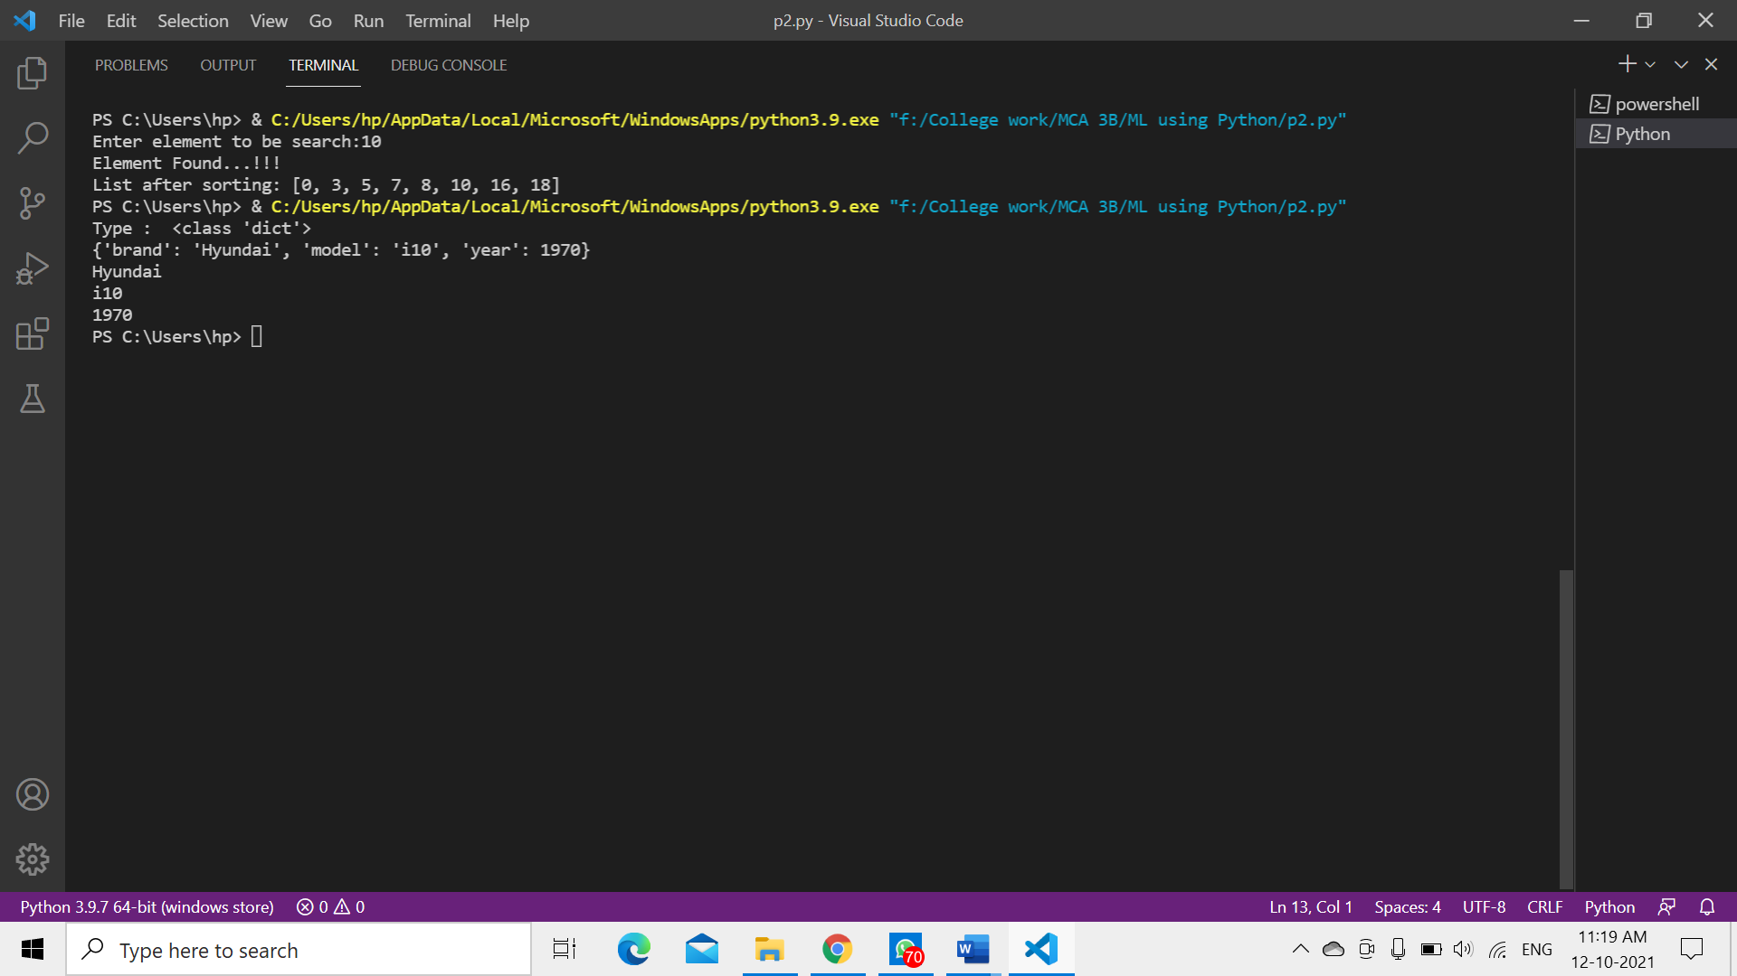

**11. Write a program to find the mean. mode and median of the given range of numbers.**

import numpy

from scipy import stats

l=[3,4,8,16,20,5,7,55,16,18,33,50,16]

print("Mean= ",numpy.mean(l))

print("Median= ",numpy.median(l))

print("Mode= ",stats.mode(l))

**OUTPUT-**

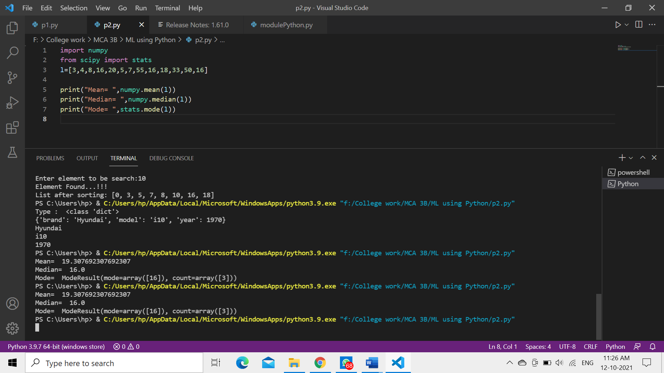

**12. Write a program to calculate the standard deviation of a given set of numbers.**

observation = [1,5,4,2,0]

sum=0

for i in range(len(observation)):

    sum+=observation[i]

mean= sum/len(observation)

sum_of_squared_deviation = 0

for i in range(len(observation)):

    sum_of_squared_deviation+=(observation[i]- mean)**2

sd = ((sum_of_squared_deviation)/len(observation))**0.5

print("Standard Deviation of sample is ",sd)

**OUTPUT-**

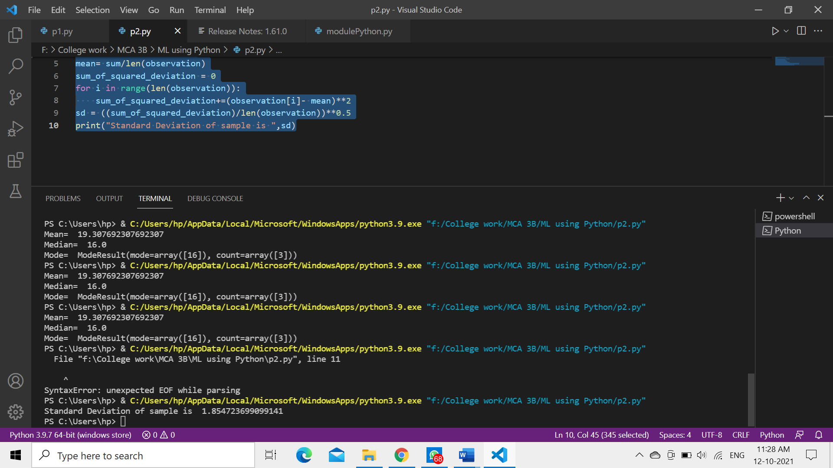

**13. Write a program to calculate the addition of two 3x 3 matrices.**

A = [[10, 13, 44],

      [11, 2, 3],

      [5, 3, 1]]

B = [[7, 16, -6],

     [9, 20, -4],

     [-1, 3 , 27]]

C = [[0,0,0],

     [0,0,0],

     [0,0,0]]

matrix_length = len(A)

for i in range(len(A)):

    for k in range(len(B)):

        C[i][k] = A[i][k] + B[i][k]

print("The sum of Matrix mat1 and mat2 = ", C)

for i in C:

    print (i)

**OUTPUT-**

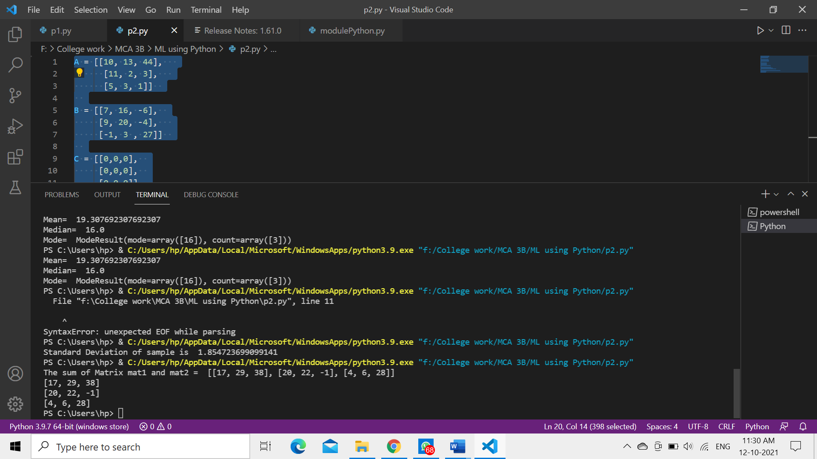

**14. Write a program to calculate the multiplication of two 3x 3 matrices.**

X = [[12,7,3],

    [4 ,5,6],

    [7 ,8,9]]

Y = [[5,8,1,2],

    [6,7,3,0],

    [4,5,9,1]]

result = [[0,0,0,0],

         [0,0,0,0],

         [0,0,0,0]]

for i in range(len(X)):

   for j in range(len(Y[0])):

       for k in range(len(Y)):

           result[i][j] += X[i][k] * Y[k][j]

print("After multiplication: ")

for r in result:

   print(r)

**OUTPUT-**

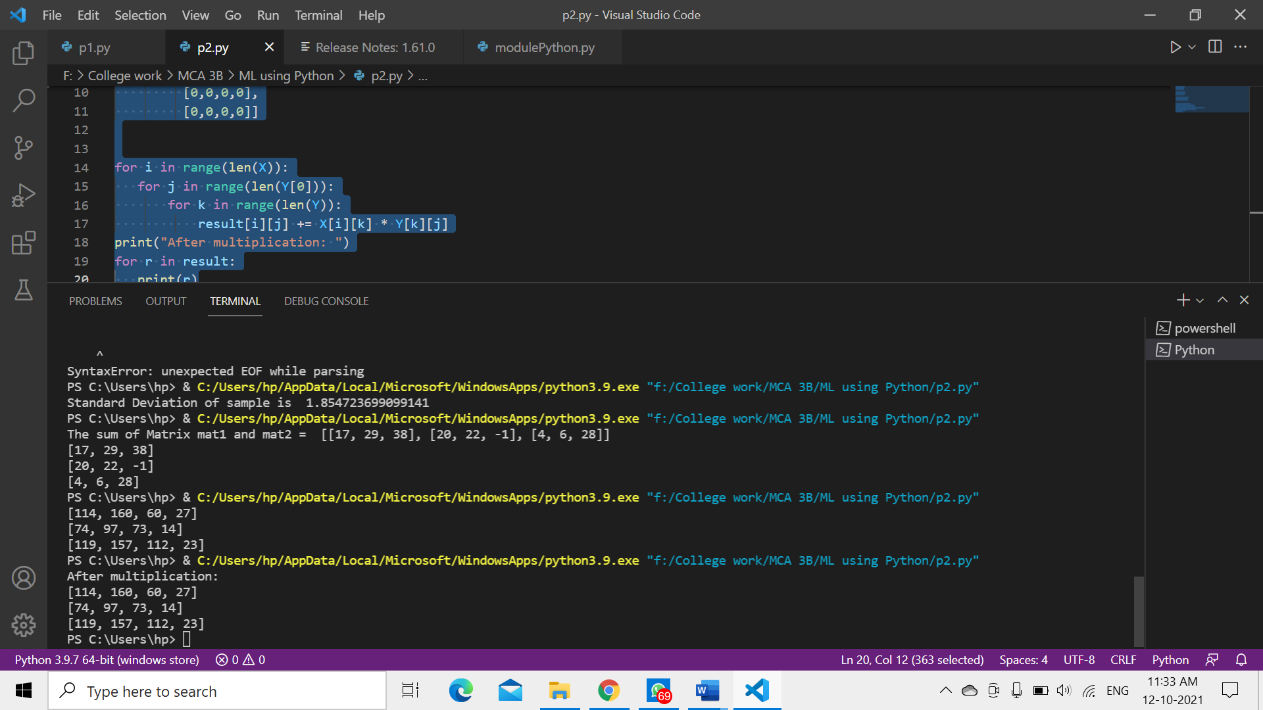

**15. Write a program to calculate the transpose of the given matrix.**

X = [[12,7,3],

    [4 ,5,6],

    [7 ,8,9]]

Transpose = [[0,0,0],

     [0,0,0],

     [0,0,0]]

for i in range(len(X)):

    for k in range(len(Transpose)):

        Transpose[i][k] = X[k][i]

print("After Transpose:")

for t in Transpose:

   print(t)

**OUTPUT-**

